

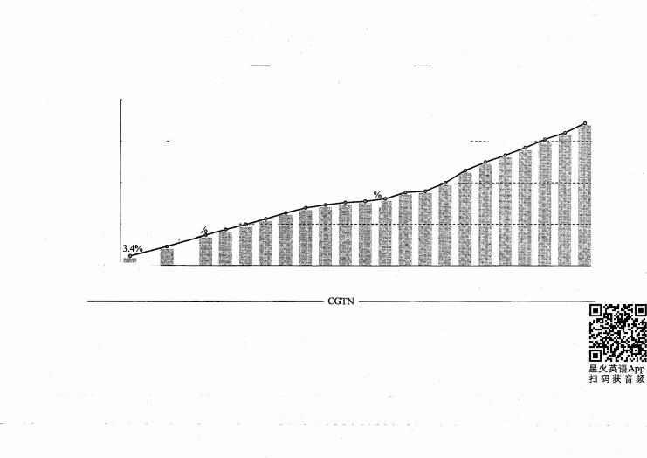

2021年6月大学英语六级考试真题（二）

**Part** I **Writing** **(30** **minutes)**

.

**Directions:** For this part, you are allowed 30 minutes to write an essay based on the chart below . You should start your essay with a brief description of the chart and comment on China's achievements in higher education . You should write at least 150 words but no more than 200 words .

**Gross** **enrolment** **ratio** **in** **higher** **education** **in** **China** **(1990** **-** **2019)**

60.0% • • •••• • • •••••• • ••••••• • • • • • • • • • • • • • • ••••••••• • • •• • • • • •• • • • • • •• • • • • • • • •••• • • •• • • • • • .... • • •••••• • • •• • • • • • • • • • • • .

48.1r?.51.6%

45.7%

42.7%

45.0% ···---- · -- · ·· ······ ---- ·· · · ······ ·· ------- · · · - ······ ------- · · · - ······ ------····· 37.5%40:00-/o ···

30014.5%

30.0% • ••· • • •·········· ---· · ·• · · · ··· - ··• --·-····- ·- ·· ·· - -- ---·- "N:2%16:S% ·· · - • ·

26.95%

19% 21o/c**0** 22%**-** 23%23.3 !

17%

··········ii········· · · ·

15.0% •••••• 13 3% 15%

6.86o/c

0.

2000 2001 20022003 20042005 2006 2007 2008 2009 20102011 201220132014 20152016 2017 2018 2019 Source: Ministry ofEducation

**Part** **][** **Listening** **Comprehension** **(30** **minutes)**

**Section** **A**

**Directions:** In this section, you will hear two long conversations . At the end of each conversation, you will hear four questions . Both the conversation and the_ questions will be spoken only once . After you hear a question , you must choose the best answer from the four choices marked A) , B) , C) and D). Then mark the corresponding letter on Answer Sheet 1 with a single line through the

centre .

**Questions** **1** **to** **4** **are** **based** **on** **the** **conversation** **you** **have** **just** **heard.**

1. A) Weird. B) Efficient.

C) Tolerant. D) Toxic.

C) They are ambitious.

D) They are accommodating. 

C) They can break conventions.

D) They can work flexible hours.

C) It enables people to learn and grow.

D) It is conducive to critical thinking.

2. A) They are arrogant.

B) They are ignorant .

3. A) They can think big.

B) They can air their views.

4. A) It can alter people's mindsets.

B) It can lead to new discoveries.

**Questions** **5** **to** **8** **are** **based** **on** **the** **conversation** **you** **have** **just** **heard.**

5. A) He kept looking for the best place to stay. C) He had a great time sightseeing and relaxing.

B) He met many tourists from other countries. D) He managed to visit a different city each day.

6. A) Prioritize what is essential to their best advantage .

B) Stretch out the process in search of the optimal .

C) Deliberate the consequences that may occur .

D) Take all relevant factors into consideration.

六级 2021 年 6 Jl 24



7 . A) Time pressure. C) Modern technology.

B) Tight budget. D) Fierce competition.

8. A) Research as many different options as possible. C) Focus on what is practical.

B) Avoid going over the same options repeatedly . D) Trust their gut instinct.

**Section** **B**

**Directions:** In this section , you will hear two passages . At the end of each passage , you will hear three or four questions . Both the passage and the questions will be spoken only once . After you hear a question , you must choose the best answer from the four choices marked A ) , B) , C) and D ) . Then mark the

corresponding letter on Answer Sheet 1 with a single line through the centre .

**Questions** **9** **to** **11** **are** **based** **on** **the** **passage** **you** **have** **just** **heard.**

9. A) It is beneficial to poor as well as rich communities.

B) It is conducive to children's future development.

C) It is welcome to parents but not to children.

D) It is not of much help to younger children .

10. A) It may put some students in remote areas at a disadvantage.

B) It gives the majority of students ready access to their teachers .

C) It effectively improves the learning quality of students in rural areas. 

D) It can bridge the learning gap between kids of different backgrounds. 

11. A) Diligent students tend to do their homework independently .

B) The focus of homework should always be on school subjects .

C) Doing homework exerts a positive effect on kids' personality development .

D) The benefits of doing homework vary widely from individual to individual .

**Questions** **12** **to** **15** **are** **based** **on** **the** **passage** **you** **have** **just** **heard.**  

 12. A) It was something he apologized for later. C) It was a forty-nine-year plan.

B) It was ridiculed by the New York Times . D) It was considered visionary.

13. A) It was of great significance to rocket science. C) It was somehow delayed about 12 minutes.

B) It was completed in the state of New Mexico. D) It failed due to a sudden change of weather.

14. A) A laboratory and test range was already set up there .

B) Its climate was ideal for year-round rocket launching.

C) A weather expert invited him to go there for his mission .

D) Its remote valleys were appealing to him and his family.

15. A) He won an award from the US government for his work.

B) He gained recognition from rocket scientists worldwide.

C) He was granted over 200 patents in rocket technology .

D) He boosted the military strength of the United States .

**Section** **C**

**Directions:** In this section, you will hear three recordings of lectures or talks followed by three or four questions . The recordings will be played only once . After you hear a question, you must choose the best answer from the four choices marked A), B), C) and D) . Then mark the corresponding letter on Answer Sheet 1 with a single line through the centre .

**Questions** **16** **to** **18** **are** **based** **on** **the** **recording** **you** **have** **just** **heard.**

16. A) It requires entrepreneurial experience. C) **It** can be quite frustrating.

B) It is usually financially rewarding. D) It can be rather risky.

17. A) **It** contributes to rapid business expansion. C) It reduces conflict among team members.

B) It inspires willingness to make sacrifices. D) It encourages creation and innovation.



18. A) They have unrealistic expectations. C) Few can find willing investors .

B) They often work without any pay. D) Many are idealistic dreamers.

**Questions** **19** **to** **21** **are** **based** **on** **the** **recording** **you** **have** **just** **heard.**

19. A) They have better dietary habits.

B) They bear fewer social responsibilities.

C) They are born with a stronger ability to socialize.

D) They are better able to survive or handle disease.

20. A) They have a limited reproductive ability. C) They keep dividing throughout one's life.

B) They depend on adequate sleep to thrive. D) They strengthen with regular exercise .

21. A) The process of ageing can ultimately be brought under control. 

B) Improved health care for the elderly will contribute to longevity.

C) Prevention of heart disease and stroke will increase life expectancy.

D) The resolution of age-related diseases will solve the mystery of ageing.

**Questions** **22** **to** **25** **are** **based** **on** **the** **recording** **you** **have** **just** **heard.**

22. A) They are reluctant to follow instructions. C) They cannot understand directives.

B) They fail to answer emails promptly. D) They do not show due respect.

23. A) They have not been trained to follow the rules. C) They want to avoid unnecessary losses.

B) They are not satisfied with the management . D) They find their voice go unheeded.

24. A) When they are on good terms with their managers. 

B) When they find their job goals easily attainable. 

C) When they find their supervisors helpful.

D) When they are financially motivated.

25. A) They are a useless tool for managers to change employee behavior.

B) They prove to be a good means for managers to give instructions . 

C) They should be reserved for urgent communication.

D) They are seldom used for sharing confidential data. 



**Part** **][** **Reading** **Comprehension** **(** **40** **minutes)**

**Section** **A**

**Directions:** In this section, there is a passage with ten blanks . You are required to select one word for each blank from a list of choices given in a word bank following the passage . Read the passage through carefully before making your choices . Each choice in the bank is identified by a letter . Please mark the corresponding letter for each item on Answer Sheet **2** with a single line through the centre . You may not use any of the words in the bank more than once .

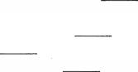I'm always baffled when I walk into a pharmacy and see shelves bursting with various vitamins, extracts and other supplements, all promising to accelerate or promote weight loss. Aisles of marketing genius belie (掩饰) the fact that, 26 , weight loss is dictated by the laws of arithmetic . Economist Jessica Irvine wrote a book about how she used math to help her lose more than 18 kilograms. If calories taken in are less than calories 27 , weight shall be lost, and so it is with money.

Despite the 28 of financial products, services and solutions geared towards accumulating wealth, if all begins with the same 29 : getting ahead financially requires a reduction of spending, so that income is greater than expenses. I was reminded of this again recently listening to an interview with Nicole Haddow, the author of Smashed Avocado, explaining how she cracked the property market at 31. It was

quite a 30 , given where she had been two years earlier.

Nicole didn't celebrate her 30th birthday as she had 31 . She was sobbing at the dinner table with

her parents, with whom she had just moved back in. She had no stable income, $12,000 in credit-card

debt and no plan, but to her 32 , her father, an accountant, told her that her financial 33 wasn't



六级 2021 年 6 月 26

as bad as she thought. He said, on her income, with some changes, she would be able to buy an

investment unit within two years, which she did. 

Nicole admitted she was fortunate, as she was able to live with her parents and 34 her spending­

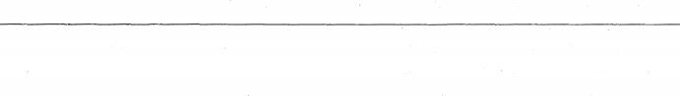and life-to get herself on track financially. Creating a gap between her income and spending required a paradigm shift ·and  sacrifice and commitment, but by going into financial lockdown, Nicole gained financial independence.

|  |  |  |  |  |  |
| --- | --- | --- | --- | --- | --- |
| A) | abundance | F) expended | | K) perm;mently | |
| B) | astonishment | G) feat | | L) plight | |
| C) | entailed | H) fiscally | | M) prosper | |
| D) | envisaged | I) | impetus | N) | shatter |
| E) | equation | J) | overhaul | 0) | ultimately |

Section B

Directions: In this section, you are going to read a passage with ter,, statements attached to it . Each



statement contains information given in one of the paragraphs . Identify the paragraph from which the

information is derived . You may choose a paragraph more than once . Each paragraph is marked with a



letter . Answer the questions by marking the corresponding letter on Answer Sheet 2.



France's beloved cathedral only minutes away from complete destruction

A) Notre Dame Cathedral in the heart of Paris was within "15 to 30 minutes" of complete destruction as

 firefighters battled to stop flames reaching its bell towers on Monday evening, French authorities have revealed. A greater disaster was averted by members of the Paris fire brigade, who risked their lives to

remain inside the burning monument to create a wall of water between the raging fire and the two towers on the west of the building.

B) The revelation of how close. France came to losing its most famous cathedral emerged as police

investigators questioned workers involved in the restoration of the monument to try to estfl.blish the  cause of the devastating blaze. Paris prosecutor Remy Heitz said that an initial fire alert was sounded at 6:20 pm on Monday evening but no fire was found. The second alert was sounded at 6:43 pm, and



the blaze was discovered on the roof.  

C) More than € 650 million was raised in a few hours on Tuesday as French business leaders and global corporations announced they would donate to a restoration campaign launched by the president, Emmanuel Macron. But as the . emergency services picked through the burnt debris, a row was resurfacing over accusations that the beloved cathedral, immortalised in Victor Hugo's novel, was

already crumbling before the fire. 



 D)  The cathedral is owned by the French state and has been at the  centre of a years-long dispute over who

should finance restoration work of the collapsing staircases, crumbling statues and cracked walls. Jean­ Michel Leniaud, the president of the scientific council at the N_ational Heritage Institute, said: "What happened was bound to happen. .The lack of adequate maintenance and daily attention to such a majestic building is the cause of this catastrophe." After the blaze was declared completely extinguished, 15 hours after it started, the junior interior minister, Laurent Nunez, said the structure had been saved but remained vulnerable. He praised the actions of the firefighters but admitted  the fate of the cathedral had been uncertain. "They saved the main structure, but it all came down to 15 -

30 minutes," Nunez said. 



E)  In a surprise televised address on Tuesday evening, Macron said he wanted to see the cathedral rebuilt



within five years. "The fire at Notre Dame reminds us that we will always have challenges to overcome," Macron said, "Notre Dame is our history, our literature, the centre of ourlife . It is the



standard by which we measure our distances. It's so many books, so many paintings. It's the cathedral 六级 2021 年 6 月 27



of every French person, even those who have never visited it . This history is ours and so we will rebuild Notre Dame. It is what the French people expect; it is what our history deserves. It is our deep destiny. We will rebuild Notre Dame so it is even more beautiful than before . I want it done in the next five years . We can do it . After the time of testing comes a time of reflection and then of action."

F) The fire, which had started at the base of the 93-metre spire (尖塔) at about 6: 40 pm on Monday, spread through the cathedral's roof, made up of hundreds of oak beams, some dating back to the 13th century. These beams, known as la foret (the forest) because of their density, formed the cross­ shaped roof that ran the length of the central part of the cathedral. As hundreds of tourists and Parisians stood and watched the flames leaping from the roof, there was shock and tears as the cathedral spire caught fire, burned and then collapsed into itself .

G) A collection of dramatic videos and photos quickly spread across social media, showing the horrifying destruction, and attracting emotional responses from people all over the world. Indeed, within minutes the fire occupied headlines of every major global newspaper and television network. This is not surprising given Notre Dame Cathedral, meaning "Our Lady", is one of the most recognised symbols of the city of Paris attracting millions of tourists every year.

H) While the world looked on, the 500 firefighters at the scene then battled to prevent the flames from reaching the two main towers, where the cathedral bells hang. If the wooden frame of the towers had caught fire, it could have sent the bells-the largest of which, the Emmanuel Bell, weighs 13 tons­ crashing down, potentially causing the collapse of both towers. Police and fire services will spend the next 48 hours assessing the "security and safety" of the 850-year-old·structure . Nunez said: "We have identified vulnerabilities throughout the structure, all of which still need securing ." As a result, residents of five buildings around the northern side of the cathedral were being temporarily evacuated, he added. Architects have identified three main holes in the structure, in the locations of the spire, the main hall and the upper rooms to the north of the central aisle. Most of the wooden roof beams have been burned, and parts of the concrete holding up the roof have collapsed .

I) The interior minister, Christophe Castaner, visited the cathedral on Tuesday afternoon to see the extent of the devastation. Ash covered the marble diamond-patterned floor and floated in large pools of grey water from the fire hoses . Behind a heap of blackened oak beams that lay piled up where they

had fallen, daylight from vast holes in the cathedral roof lit a golden cross over a statue by Nicolas

Coustou, which appeared to have escaped- damage . Preliminary inspections also suggested -the three ornate (装饰华丽的) stained glass "rose" windows appeared to have survived the fire, officials said. However, fire officers have said a complete inventory of the damage will not be possible until the cathedral structure has been deemed safe.

J) The culture minister, Franck Riester, said religious relics saved from the cathedral were being securely held at the Hotel de Ville, and works of art that sustained smoke damage were being taken to the Louvre, the world's largest art museum, where they would be dried out, repaired and stored . Sixteen copper statues that decorated the spire had been removed for restoration only a few days before the fire. Relics at the top of the spire are believed lost as the spire was destroyed. As well as damage from the heat, which firefighters said reached more than 800 ·c , experts also need to assess damage from the vast quantities of water firefighters poured into the cathedral. One casualty of this was The Great Organ constructed in the 1730s, which was said to have escaped the flames but been significantly damaged by water.

K) French political commentators noted the devastating fire had succeeded where Macron had failed in uniting the country . But criticism over the original state of the building is likely to intensify over coming days. Leniaud told La Croix newspaper: "This is not about looking for people to blame . The responsibility is collective because this is the most loved monument in the country." Alexandre Gady, an art historian, agreed. "We've been saying for years that the budget for maintaining historic

六级 2021 年 6 月 28

monuments is too low," Gady said. The Paris prosecutor's office has opened an inquiry into "involuntary destruction by fire", indicating they believe the cause of the blaze was accidental rather than criminal .

36. The total amount of 1amage to Notre Dame Cathedral can be assessed only when its structure is considered safe .

37. Once again people began to argue whether Notre Dame Cathedral was going to collapse even without the fire .

38. The Notre Dame Cathedral catastrophe was said to have helped unite the French nation .

39. The roof of Notre Dame Cathedral was built with large numbers of densely laid-out wood beams .

40. Renovation workers of Notre Dame Cathedral were questioned to find out the cause of the accident .

41. Had the bell towers' wooden frames burned down, the heavy bells would have crashed down.

42. The timely action of the firefighters prevented the fire from  reaching the Cathedral's bell towers .

43. Apart from the fire, the water used to extinguish it also caused a lot of damage to Notre Dame Cathedral.

44. There has been argument over the years as to who should pay for the restoration of Notre Dame Cathedral .

 45. News of the Notre Dame Cathedral catastrophe instantly caught media attention throughout the world .

**Section** **C**

**Directions:** There are 2 passages in this section . Each passage is fallowed by some questions or unfinished statements . For each of them there are four choices marked A), B), C) and D) . You should decide on the

best choice and mark the corresponding letter on Answer Sheet **2** with a single line through the centre .

**Passage** **One** 

**Questions** **46** **to** **50** **are** **based** **on** **the** **following** **passage.**

We often think of drawing as something that takes inborn talent, but this kind of thinking stems from our misclassification of drawing as, primarily, an art form rather than a tool for learning .

Researchers, teachers, and artists are starting to see how drawing can positively impact a wide variety of skills and disciplines .

Most of us have spent some time drawing before, but at some point, most of us stop drawing . There are people who don't, obviously, and thank god for that: a world without designers and artists would be a

very shabby one indeed .  

Some argue that so many adults have abandoned drawing because we've miscategorized it and given it a very narrow definition . In his book, Stick Figures: Drawing as a Human Practice, Professor D. B . Dowd argues that we have misfiled the significance of drawing because we see it as a professional skill instead of a personal capacity. We mistakenly think of "good" drawings as those which work as recreations of the real world, as realistic illusions . Rather, drawing should be recategorized as a symbolic tool .

Human beings have been drawing for 73,OOO years. It's part of what it means to be human. We don't have the strength of chimpanzees (大猩猩) because we've given up animal strength to manipulate subtle instruments, like hammers, spears, and-later-pens and pencils. The human hand is an extremely dense network of nerve endings . In many ways, human beings are built to draw.

Some researchers argue that doodling ( 涂  ) activates the brain's so-called default circuit- essentially, the areas of the brain responsible for maintaining a baseline level of activity in the absence of other stimuli. Because of this, some believe that doodling during a boring lecture can help students pay attention . In one study, participants were asked to listen to a list of names while either doodling or sitting still. Those who doodled remembered 29 percent more of the names than those who did not.

 There's also evidence that drawing talent is based on how accurately someone perceives the world . The human visual system tends to misjudge size, shape, color, and angles but artists perceive these

六级 2021 年 6 月 29



qualities more accurately than non-artists . Cultivating drawing talent can become an essential tool to improve people's observational skills in fields where the visual is important.

Rather than ·think of drawing as a talent that some creative people are gifted in, we should consider it as a tool for seeing and understanding the world better-one that just so happens to double as an art form . Both absent-minded doodling and copying from life have been shown to positively affect your memory and visual perception, so complain loudly the next time your school board slashes the art department's budget .

46. What do people generally think about drawing?

A) It is a gift creative people are endowed with. C) It is an art form that is appreciated by all.

B) It is a skill that is acquired with practice . D) It is an ability everyone should cultivate .

47. What do we learn about designers and artists?

A) They are declining gradually in number .

B) They are keen on changing shabby surroundings .

C) They add beauty and charm to the world .

D) They spend most of their lives drawing .

48. What does Professor D . B. Dowd argue in his book?

A) Everybody is born with the capacity to draw .

B) Drawing is a skill that requires special training .

C) The value of drawing tends to be overestimated .

D) Drawing should be redefined as a realistic illusion .

49. What have some researchers found from one study about doodling?

A) It is a must for maintaining a base level of brain activity .

B) It can turn something boring into something interesting .

 C) It is the most reliable stimulant to activate the brain .

D) It helps improve concentration and memory .

50. What is characteristic of people with drawing talent?

A) Sensitivity to cognitive stimulation . C) Accuracy in categorization .

B) Subtlety of representation . D) Precision in visual perception .

**Passage** **Two**

 **Questions** **51** **to** **SS** **are** **based** **on** **the** **following** **passage.**

The car has reshaped our cities . It seems to offer autonomy for everyone . There is something almost delightful in the detachment from reality of advertisements showing mass-produced cars marketed as symbols of individuality and of freedom when most of their lives will be spent making short journeys on choked roads .

For all the fuss made about top speeds, cornering ability and acceleration, the most useful gadgets on a modern car are those which work when you're going very slowly: parking sensors, sound systems, and navigation apps which will show a way around upcoming traffic jams . This seems to be  one of the few areas where the benefit of sharing personal information comes straight back to the sharer: because these apps know where almost all the users are, and how fast they are moving almost all the time, they can spot traffic congestion (堵塞) very quickly and suggest ways round it .

The problem comes when everyone is using a  navigation app which tells them to avoid everyone else using the same gadget . Traffic jams often appear where no one has enough information to avoid them . When a lucky few have access to the knowledge, they will benefit greatly . But when everyone has perfect information, traffic jams simply spread onto the side roads that seem to offer a way round them .

This new congestion teaches us two things . The first is that the promises of technology will never be realised as fully as we hope; they will be limited by their unforeseen and unintended consequ,ences . Sitting in a more comfortable car in a different traffic jam is pleasant but hardly the liberation that once seemed to be promised . The second is that self-organisation will not get us where we want to go. The efforts of

六级 2021  6 月 30

millions of drivers to get ahead do not miraculously produce a situation in which everyone does better than before’ but one in which almost everyone does rather worse. Central control and collective organisation can produce smoother and fairer outcomes’though even that much is never guaranteed .

Similar limits can be foreseen for the much greater advances promised by self~driving cars. Last week’ one operated by the taxi company Uber struck and killed a woman pushing her bicycle across a wide road in Arizona . This was the first recorded death involving a car which was supposed to be fully

autonomous. Bxperts have said that it suggests a "catastrophic failure" of technology . 

Increasingly’ even Silicon Valley has to acknowledge the costs of the intoxicating (令人 陶 醉 的) hurry that characterises its culture . What traffic teaches us is that reckless and uncontrolled change is as likely to harm us as it is to benefit us’and that thoughtful regulation is necessary for a better future .

51. What does the author say about car advertisements? 

A) They portray drivers who enjoy speed on the road .

B) They present a false picture of the autonomy cars provide .

C) They pursue individuality and originality in design concept.

D) They overestimate the potential market of autonomous cars.

52. What does the author imply about the various gadgets on cars? 

A) They can help to alleviate traffic jams.

B) Most of them are as effective as advertised.

C) .Only some can be put to use under current traffic conditions .

D) They are constantly upgraded to make driving easier and safer .

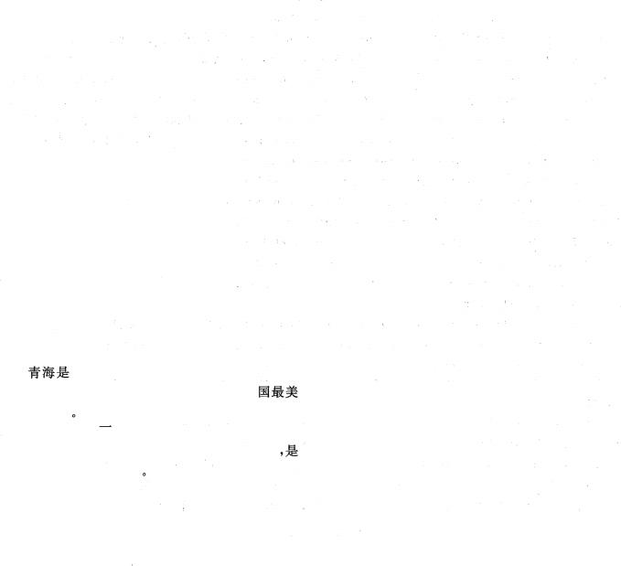53. What does the author say about the use of navigation apps?

A) It is likely to create traffic jamsin other places.

B) It helps a great deal in easing traffjc congestion .

C) It sharply reduces the incidence of traffic accidents .

D)；It benefits those who are learning to drive .

54. What does the author say about technology?

A) Its consequences are usually difficult to assess .

B) It seldom delivers all the benefits as promised .

C) It depends on the required knowledge for application .

D) Its benefits are guaranteed by collective wisdom .

55. What key message does the author try to convey in the passage? 

A) The consequences of technological innovation need not be exaggerated .

B) There is always a price to pay to develop techn，ology for a better world .

C) Technological innovation should be properly reEulated .

D) The culture of Silicon Valley ought not to be emulated.

**Part** Ⅳ **Translation** **(** **30** **minutes)**

**Directions:** For this part, you are allowed 30 minutes to translate a passage from Chinese into English . You should write your answer on Answer Sheet **2.**

中国西北部 的一.个省 份 , 平均海拔3000米以 上 大部 分地 区 为 高山和 高 原，青 海 省得名于全

国最大的咸水糊青海湖 **O** 青海湖被誉为"中国最美的湖泊，是最受欢迎的景点之一 ，也是摄影师和艺

术家的天堂

青海山川壮丽，地大 物博 !石 油 和 天然 气储量丰富 ! 省内许 多 城 市 的 经 济 在石 油 和 天然气 的带动下

得到了长足发展，青海尤 以 水资源丰富而闻名，是中国三大河流长江、黄河 和澜沧江 的 发源 地 ’在中国的水

生态 中 发挥着重要作用

六级 2021 年 6 月 31